**Steps to install the JBOSS:**

* Firstly install the java
* Now install the jboss
* wget <https://github.com/wildfly/wildfly/releases/download/28.0.1.Final/wildfly-28.0.1.Final.tar.gz>
* then untar the file
* cd wildyfy ...
* then go to the /standalone >> confriguration >> vi standalone.xml
* change the ip address at the three places

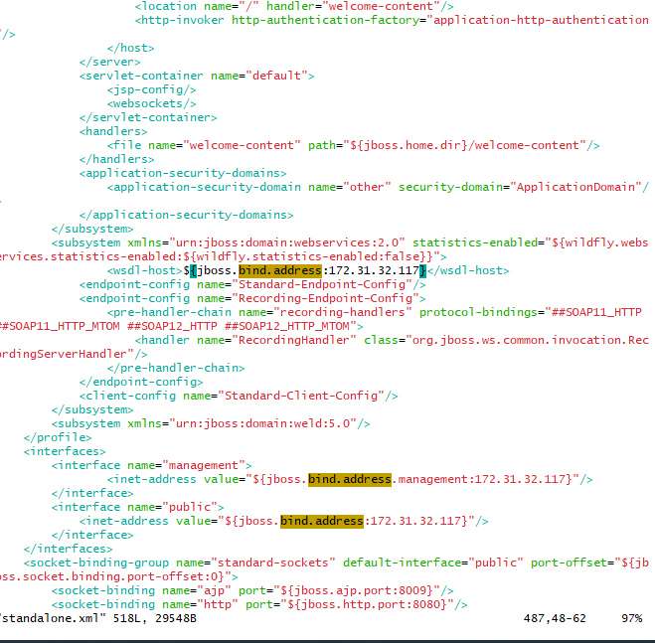

* Save and exit
* then go to /bin and add user
* sh add-user.sh
* add management user
* then give the username and password
* sh standalone.sh
* put ip:8080

**Steps to install the nginx:**

Yum install nginx

systemctl start nginx

sytsemctl enable nginx

systemctl status nginx